Instructor Teaching Tracker

Brandon R. Russell

University of Maryland University College

Contents

Statement of Work 3

Entity Relationship Diagram 4

Table Design 5

Data Definition 6

Insert Data 13

Queries 18

Conclusion 27

# Statement of Work

1. This database supports the Instructor Teaching Tracker application. It keeps track of Instructor, course, and section data, as well as classes taught and schedule. The purpose of this is to assist Instructors with scheduling/maintaining classes in an efficient manner.

The Instructor table has the name, address, phone number and section number. The course list has the course name, author, description, hours and section number. The section table has the section number, name, address and field of study. The Instructor Classes table shows the Instructor, schedule, course, room number and Instructor notes. The class schedule gives the day/time a class is taught, a down day schedule and notes.

For this application a section can have many Instructors, but an Instructor can only belong to one section. A section can control many courses, but a course can belong to only one section. An instructor can teach many classes and a class can be taught by many instructors; this is handled with an associative entity. Many classes can be generated from one course, but each class can only be generated from a single course. One class can have only one schedule, while many classes can have the same schedule.

Assumptions: This application tracks classes taught by instructors and includes a class schedule. It is assumed classes will always meet a specific schedule criteria of Monday-Wednesday-Friday, Tuesday-Thursday, or Saturday. Down days are tracked for individual classes since this will vary based upon the specific class.

1. Database: Oracle 11g on Windows platform.
2. Software: ER Assistant, Oracle SQL developer, and Oracle SQL developer data modeler.
3. DDL – drop and create the database objects including tables, views, triggers, and sequences. DML – populate and query data.

# Entity Relationship Diagram

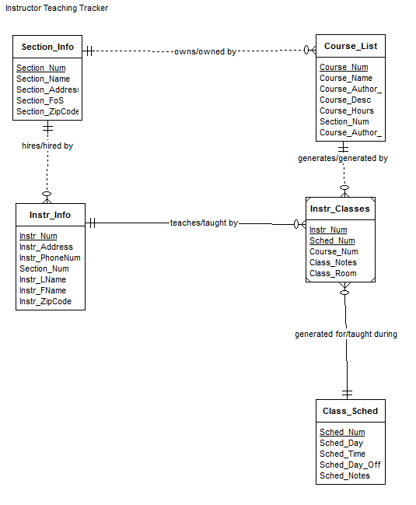

# Table Design

|  |  |  |
| --- | --- | --- |
| Section_Info | | |
| Section_Num | INTEGER | Not null - pk |
| Section_Name | VARCHAR(100) |  |
| Section_Address | VARCHAR(100) |  |
| Section_FoS | VARCHAR(100) |  |
| Section_ZipCode | VARCHAR(10) |  |

|  |  |  |
| --- | --- | --- |
| Course_List | | |
| Course_Num | INTEGER | Not null – pk |
| Course_Name | VARCHAR(100) |  |
| Course_Author_FName | VARCHAR(20) |  |
| Course_Author_LName | VARCHAR(20) |  |
| Course_Desc | VARCHAR(1000) |  |
| Course_Hours | INTEGER |  |
| Section_Num | INTEGER | Not null - fk |

|  |  |  |
| --- | --- | --- |
| Instr_Info | | |
| Instr_Num | INTEGER | Not null – pk |
| Instr_Address | VARCHAR(100) |  |
| Instr_PhoneNum | VARCHAR(20) |  |
| Section_Num | INTEGER | Not null - fk |
| Instr_LName | VARCHAR(20) |  |
| Instr_FName | VARCHAR(20) |  |
| Instr_ZipCode | VARCHAR(10) |  |

|  |  |  |
| --- | --- | --- |
| Class_Sched | | |
| Sched_Num | INTEGER | Not null - pk |
| Sched_Day | VARCHAR(100) |  |
| Sched_Time | VARCHAR(10) |  |
| Sched_Day_Off | VARCHAR(100) |  |
| Sched_Notes | VARCHAR(1000) |  |

|  |  |  |
| --- | --- | --- |
| Instr_Classes | | |
| Instr_Num | INTEGER | Not null – pk/fk |
| Sched_Num | INTEGER | Not null – pk/fk |
| Course_Num | INTEGER | Not null - fk |
| Class_Notes | VARCHAR(1000) |  |
| Class_Room | VARCHAR(5) |  |

# Data Definition

SET echo on

SET serveroutput on

**/* Drop tables, sequence, and other objects you create*/**

DROP TABLE Instr_Classes;

Table INSTR_CLASSES dropped.

DROP TABLE Instr_Info;

Table INSTR_INFO dropped.

DROP TABLE Course_List;

Table COURSE_LIST dropped.

DROP TABLE Section_Info;

Table SECTION_INFO dropped.

DROP TABLE Class_Sched;

Table CLASS_SCHED dropped.

DROP SEQUENCE SectionNum_Seq;

Sequence SECTIONNUM_SEQ dropped.

DROP SEQUENCE InstrNum_Seq;

Sequence INSTRNUM_SEQ dropped.

DROP SEQUENCE CourseNum_Seq;

Sequence COURSENUM_SEQ dropped.

DROP SEQUENCE SchedNum_Seq;

Sequence SCHEDNUM_SEQ dropped.

**/* Create 5 tables */**

CREATE TABLE Section_Info

(

Section_Num INTEGER NOT NULL,

Section_Name VARCHAR (100),

Section_Address VARCHAR (100),

Section_FoS VARCHAR (100),

Section_ZipCode VARCHAR(10),

CONSTRAINT pk_section PRIMARY KEY (Section_Num)

);

Table SECTION_INFO created.

DESCRIBE Section_Info;

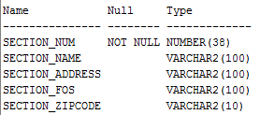

CREATE TABLE Instr_Info

(

Instr_Num INTEGER NOT NULL,

Instr_Address VARCHAR (100),

Instr_PhoneNum VARCHAR (20),

Section_Num INTEGER NOT NULL,

Instr_LName VARCHAR (20),

Instr_FName VARCHAR (20),

Instr_ZipCode VARCHAR (10),

CONSTRAINT pk_Instr PRIMARY KEY (Instr_Num),

CONSTRAINT fk_Instr_Section FOREIGN KEY (Section_Num)

REFERENCES Section_Info

);

Table INSTR_INFO created.

DESCRIBE Instr_Info;

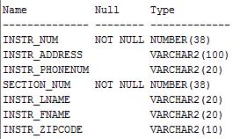

CREATE TABLE Course_List

(

Course_Num INTEGER NOT NULL,

Course_Name VARCHAR (100),

Course_Author_FName VARCHAR (20),

Course_Author_LName VARCHAR(20),

Course_Desc VARCHAR (1000),

Course_Hours INTEGER,

Section_Num INTEGER NOT NULL,

CONSTRAINT pk_Course PRIMARY KEY (Course_Num),

CONSTRAINT fk_Course_Section FOREIGN KEY (Section_Num)

REFERENCES Section_Info

);

Table COURSE_LIST created.

DESCRIBE Course_List;

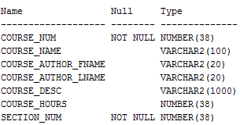

CREATE TABLE Class_Sched

(

Sched_Num INTEGER NOT NULL,

Sched_Day VARCHAR (100),

Sched_Time VARCHAR (10),

Sched_Day_Off VARCHAR (100),

Sched_Notes VARCHAR (1000),

CONSTRAINT pk_Schedule PRIMARY KEY (Sched_Num)

);

Table CLASS_SCHED created.

DESCRIBE Class_Sched;

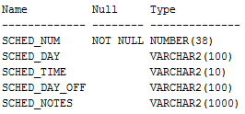

CREATE TABLE Instr_Classes

(

Instr_Num INTEGER NOT NULL,

Sched_Num INTEGER NOT NULL,

Course_Num INTEGER NOT NULL,

Class_Notes VARCHAR (1000),

Class_Room VARCHAR (5),

CONSTRAINT pk_Class PRIMARY KEY (Instr_Num, Sched_Num),

CONSTRAINT fk_Instr FOREIGN KEY (Instr_Num)

REFERENCES Instr_Info

ON DELETE CASCADE,

CONSTRAINT fk_Sched FOREIGN KEY (Sched_Num)

REFERENCES Class_Sched

ON DELETE CASCADE,

CONSTRAINT fk_Course FOREIGN KEY (Course_Num)

REFERENCES Course_List

ON DELETE CASCADE

);

Table INSTR_CLASSES created.

DESCRIBE Instr_Classes;

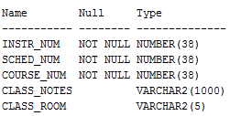

**/* Create indexes on foreign keys*/**

CREATE INDEX fk_Course_List on Course_List(Section_Num);

Index FK_COURSE_LIST created.

CREATE INDEX fk_Instr on Instr_Info(Section_Num);

Index FK_INSTR created.

CREATE INDEX fk_InstrClass on Instr_Classes(Instr_Num);

Index FK_INSTRCLASS created.

CREATE INDEX fk_ClassSched on Instr_Classes(Sched_Num);

Index FK_CLASSSCHED created.

CREATE INDEX fk_CourseClass on Instr_Classes(Course_Num);

Index FK_COURSECLASS created.

**/* Create 2 views */**

**/*This view shows all classes Instructor 1 is teaching on Schedule 1 */**

CREATE OR REPLACE VIEW Instr_Teaching_View AS

SELECT * from Instr_Classes

WHERE Instr_Num ='1' AND Sched_Num ='1';

View INSTR_TEACHING_VIEW created.

DESCRIBE Instr_Teaching_View;

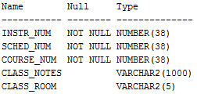

**/*This view will show which section each Instructor belongs to*/**

CREATE OR REPLACE VIEW Section_Instructors_View AS

SELECT section_num, s.section_name, i.instr_fname, i.instr_lname

FROM section_info s

INNER JOIN instr_info i

USING (section_num);

View SECTION_INSTRUCTORS_VIEW created.

DESCRIBE Section_Instructors_View;

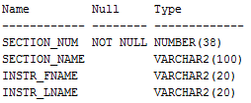

**/* Create trigger */**

**/*This trigger will display a message when a row is added to Instr_Classes*/**

CREATE OR REPLACE TRIGGER SchedClass_Trigger AFTER INSERT ON Instr_Classes

FOR EACH ROW

BEGIN

dbms_output.put_line ('A class has been added!!');

END;

/

Trigger SCHEDCLASS_TRIGGER compiled

**/* Create sequence*/**

CREATE SEQUENCE SectionNum_Seq

START WITH 1

INCREMENT BY 1;

Sequence SECTIONNUM_SEQ created.

CREATE SEQUENCE InstrNum_Seq

START WITH 1

INCREMENT BY 1;

Sequence INSTRNUM_SEQ created.

CREATE SEQUENCE CourseNum_Seq

START WITH 1

INCREMENT BY 1;

Sequence COURSENUM_SEQ created.

CREATE SEQUENCE SchedNum_Seq

START WITH 1

INCREMENT BY 1;

Sequence SCHEDNUM_SEQ created.

**/* Data Dictionary query */**

PURGE recyclebin;

**/*The next query returns the first 20 characters of all table names and then their tablespace names*/**

SELECT /*fixed*/ substr(table_name, 1,20) as name, tablespace_name from user_tables;

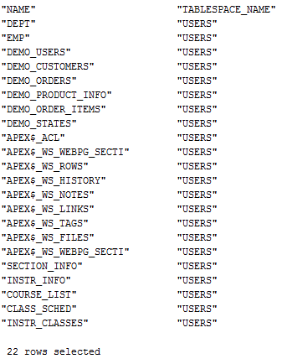

# Insert Data

**/* Insert 10 or more rows into each table */**

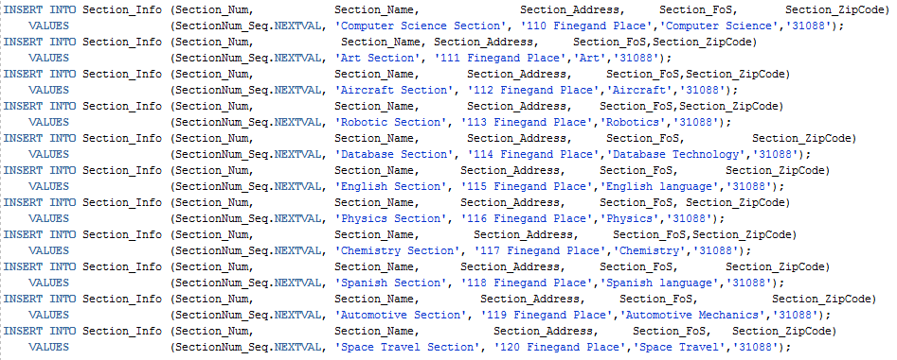

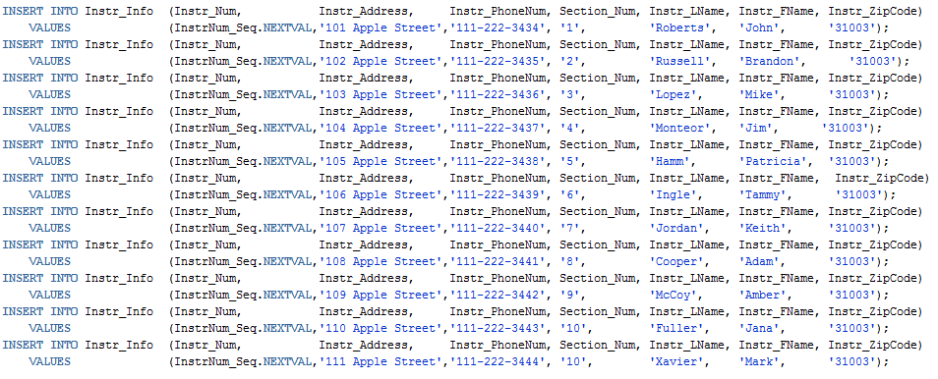

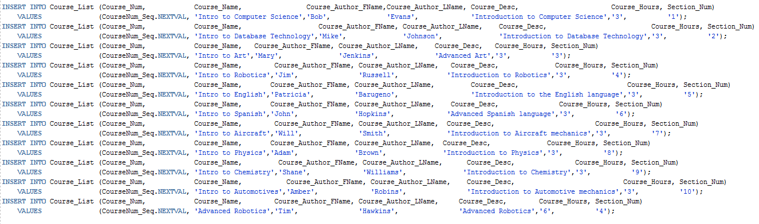

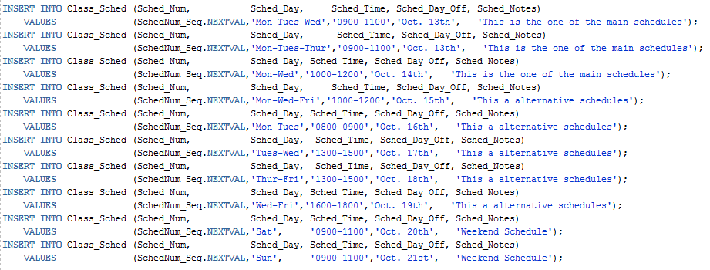

INSERT INTO Instr_Classes (Instr_Num, Sched_Num, Course_Num, Class_Notes, Class_Room)

VALUES ('1', '1', '1', 'Computer one is broke in this room','A');

1 row inserted.

A class has been added!!

INSERT INTO Instr_Classes (Instr_Num, Sched_Num, Course_Num, Class_Notes, Class_Room)

VALUES ('2', '2', '2', 'Room Ready','B');

1 row inserted.

A class has been added!!

INSERT INTO Instr_Classes (Instr_Num, Sched_Num, Course_Num, Class_Notes, Class_Room)

VALUES ('3', '3', '3', 'The Instructor Chair is broke','C');

1 row inserted.

A class has been added!!

INSERT INTO Instr_Classes (Instr_Num, Sched_Num, Course_Num, Class_Notes, Class_Room)

VALUES ('4', '4', '4', 'A/C is not working','D');

1 row inserted.

A class has been added!!

INSERT INTO Instr_Classes (Instr_Num, Sched_Num, Course_Num, Class_Notes, Class_Room)

VALUES ('5', '5', '5', 'Computer two is broke in this room','E');

1 row inserted.

A class has been added!!

INSERT INTO Instr_Classes (Instr_Num, Sched_Num, Course_Num, Class_Notes, Class_Room)

VALUES ('6', '6', '6', 'No whiteboard in this room','F');

1 row inserted.

A class has been added!!

INSERT INTO Instr_Classes (Instr_Num, Sched_Num, Course_Num, Class_Notes, Class_Room)

VALUES ('7', '7', '7', 'Student station 3 is missing a keyboard','G');

1 row inserted.

A class has been added!!

INSERT INTO Instr_Classes (Instr_Num, Sched_Num, Course_Num, Class_Notes, Class_Room)

VALUES ('8', '8', '8', 'Room Ready','H');

1 row inserted.

A class has been added!!

INSERT INTO Instr_Classes (Instr_Num, Sched_Num, Course_Num, Class_Notes, Class_Room)

VALUES ('9', '9', '9', 'Room Ready','I');

1 row inserted.

A class has been added!!

INSERT INTO Instr_Classes (Instr_Num, Sched_Num, Course_Num, Class_Notes, Class_Room)

VALUES ('10', '10', '10', 'Room Ready','J');

1 row inserted.

A class has been added!!

INSERT INTO Instr_Classes (Instr_Num, Sched_Num, Course_Num, Class_Notes, Class_Room)

VALUES ('10', '9', '10', 'Room Ready','J');

1 row inserted.

A class has been added!!

INSERT INTO Instr_Classes (Instr_Num, Sched_Num, Course_Num, Class_Notes, Class_Room)

VALUES ('9', '8', '10', 'Room Ready','X');

1 row inserted.

A class has been added!!

INSERT INTO Instr_Classes (Instr_Num, Sched_Num, Course_Num, Class_Notes, Class_Room)

VALUES ('1', '2', '9', 'Room Ready','Z');

1 row inserted.

A class has been added!!

commit;

Commit complete.

**/* Verify that each table has 10 or more rows of data */**

SELECT /*fixed*/ * FROM Section_Info;

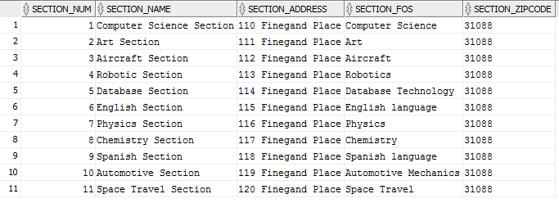

SELECT /*fixed*/ * FROM Instr_Info;

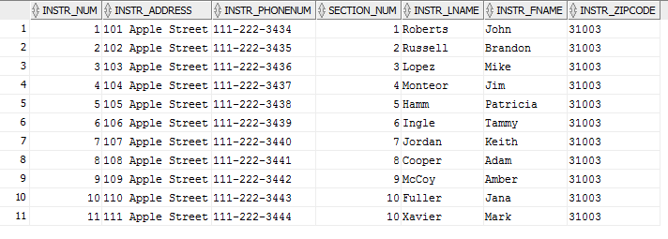

SELECT /*fixed*/ * FROM Course_List;

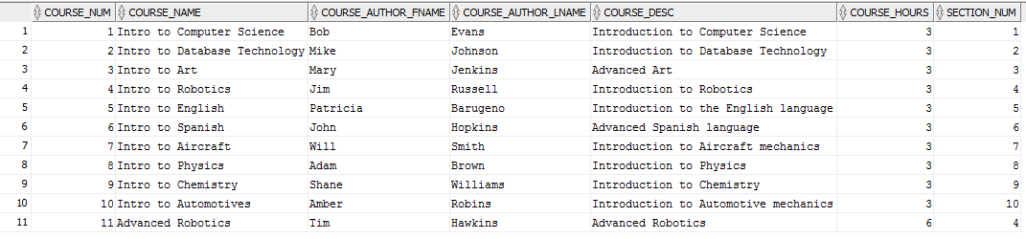

SELECT /*fixed*/ * FROM Class_Sched;

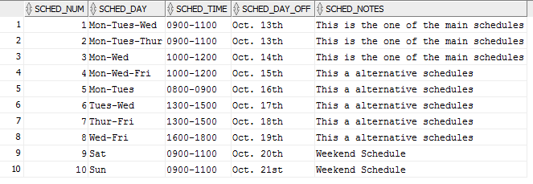

SELECT /*fixed*/ * FROM Instr_Classes;

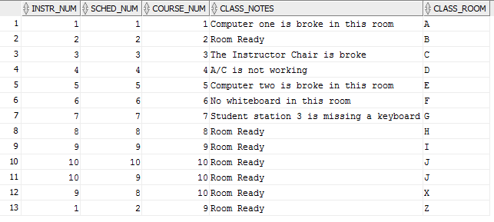

# Queries

**/*1. Select all columns and all rows from one table.*/**

SELECT /*fixed*/ * FROM Instr_Info;

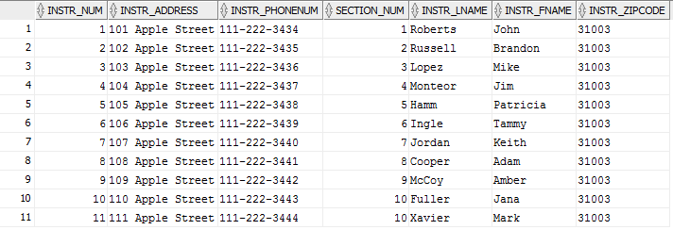

**/*2. Select 5 columns and all rows from one table. */**

SELECT /*fixed*/ Sched_Num, Sched_Day, Sched_Time, Sched_Day_Off, Sched_Notes FROM Class_Sched;

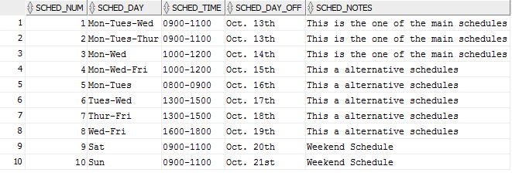

**/*3. Select all columns and all rows from 2 tables (need a join).*/**

SELECT /*fixed*/ * FROM Section_Info INNER JOIN Course_List USING (Section_Num);

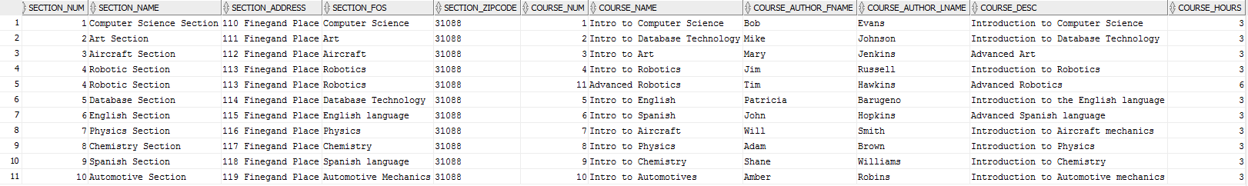

**/*4. Select and Order data retrieved from one table */**

SELECT /*fixed*/ * FROM Instr_Info ORDER BY Instr_LName;

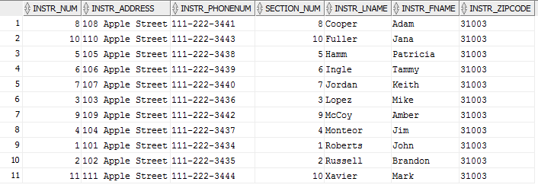

**/*5. Select 5 columns and 10 rows from 3 tables (need joins).*/**

SELECT /*fixed*/ a.Instr_LName, a.Instr_FName, b.Class_Room, c.Sched_Day, c.Sched_Time

FROM (Instr_Info a INNER JOIN Instr_Classes b ON a.Instr_Num=b.Instr_Num)

INNER JOIN Class_Sched c ON b.Sched_Num=c.Sched_Num

WHERE ROWNUM < 11;

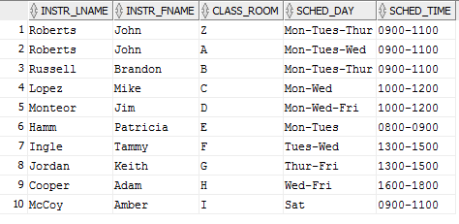

**/*6. Select distinct rows using joins using 3 tables.*/**

SELECT DISTINCT /*fixed*/ a.Instr_LName, a.Instr_FName, c.Course_Name

FROM (Instr_Info a INNER JOIN Instr_Classes b ON a.Instr_Num=b.Instr_Num)

INNER JOIN Course_List c ON b.Course_Num=c.Course_Num;

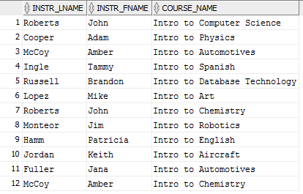

**/*7. Select all columns and 10 rows from 2 tables (need a join).*/**

SELECT /*fixed*/ * FROM Section_Info INNER JOIN Instr_Info ON

Section_Info.Section_Num=Instr_Info.Section_Num

WHERE ROWNUM < 11;

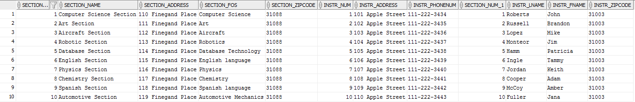

**/*8. Use group by & having in a select statement using one or more table(s).*/**

SELECT /*fixed*/ Course_Name, AVG(Course_Hours) FROM Course_List

GROUP BY Course_Name

HAVING AVG(Course_Hours) = 3;

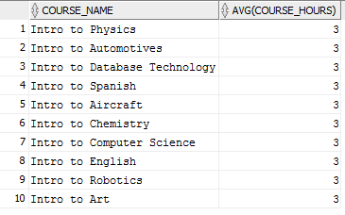

**/*9. Use a IN clause to select data from one or more tables*/**

SELECT /*fixed*/ * FROM Instr_Info WHERE Instr_LName IN ('Roberts', 'Russell');



**/*10. Select Length of one column from one table (use Length function)*/**

SELECT /*fixed*/ Course_Desc, LENGTH (Course_Desc) FROM Course_List;

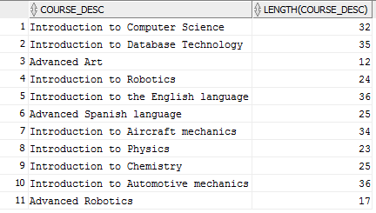

**/*11. Use a column alias*/**

SELECT /*fixed*/ Instr_FName AS InstructorName FROM Instr_Info;

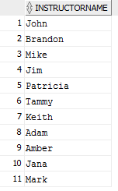

**/*12. Perform an advanced query of your choice from chapter 8 (Database Systems Text Book - Coronel, Morris & Rob)*/**

**/*Return Instructor Full Name in following format: Last, First*/**

SELECT /*fixed*/ Instr_LName || ', ' || Instr_FName AS InstructorName FROM Instr_Info;

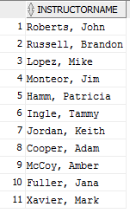

**/*13. Use an aggregate function and perform another query*/**

**/*Return total number of course hours taught for each active class*/**

SELECT /*fixed*/ Course_Name, SUM(Course_Hours) AS Total_Hours

FROM Course_List INNER JOIN Instr_Classes ON Course_List.Course_Num=Instr_Classes.Course_Num

GROUP BY Course_Name;

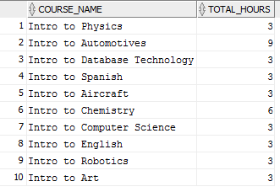

**/*14. Use the UPDATE command and change some data.*/**

SELECT /*fixed*/ * FROM Course_List;

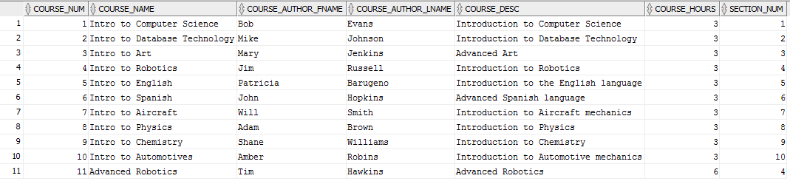

UPDATE Course_List SET Course_Hours=Course_Hours+1;

11 rows updated.

SELECT /*fixed*/ * FROM Course_List;

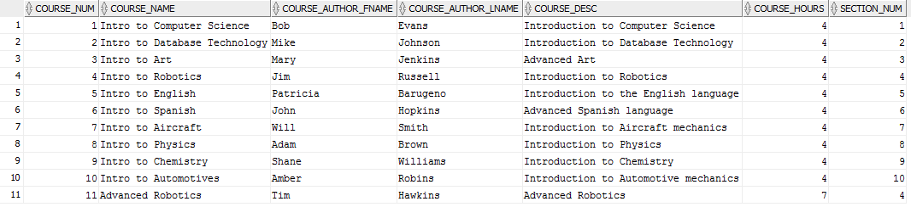

ROLLBACK;

Rollback complete.

**/*15. Write an advanced SQL statement with a type I subquery (chapter 8).*/**

**/*Return list of Instructors teaching classes with "Auto" in course name using Type I query*/**

SELECT /*fixed*/ Instr_Num, Instr_LName, Instr_FName

FROM Instr_Info

WHERE Instr_Num IN

(SELECT Instr_Num FROM Instr_Classes INNER JOIN Course_List

ON Instr_Classes.Course_Num=Course_List.Course_Num

WHERE Course_Name LIKE '%Auto%');

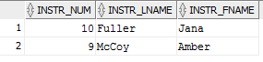

**/*16. Write an advanced SQL statement with type II subquery (chapter 8).*/**

**/*Return list of Instructors teaching classes with "Auto" in course name using Type II query*/**

SELECT /*fixed*/ Instr_Num, Instr_LName, Instr_FName

FROM Instr_Info

WHERE EXISTS

(SELECT * FROM Instr_Classes INNER JOIN Course_List

ON Instr_Classes.Course_Num=Course_List.Course_Num

WHERE Instr_Info.Instr_Num=Instr_Classes.Instr_Num

AND Course_Name LIKE '%Auto%');

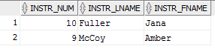

**/*17. Perform additional advanced SQL statement. (chapter 8).*/**

**/*Return a list of courses and how many times they are currently being taught*/**

SELECT /*fixed*/ Course_Name, COUNT(Instr_Classes.Course_Num) AS TimesTaught

FROM Course_List LEFT JOIN Instr_Classes

ON Instr_Classes.Course_Num=Course_List.Course_Num

GROUP BY Course_Name

ORDER BY TimesTaught;

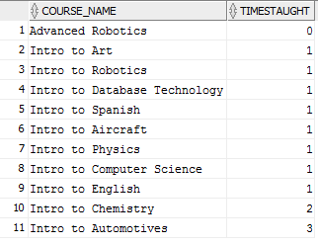

**/*18. Perform additional advanced SQL statement. (chapter 8).*/**

**/*Return all Instructor names, class rooms, and courses taught*/**

SELECT /*fixed*/ a.Instr_LName, a.Instr_FName, b.Class_Room, c.Course_Name

FROM (Instr_Info a LEFT JOIN Instr_Classes b ON a.Instr_Num=b.Instr_Num)

LEFT JOIN Course_List c ON b.Course_Num=c.Course_Num;

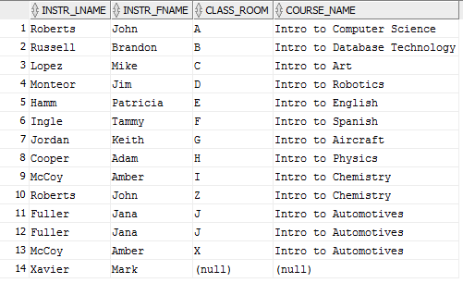

**/*19. Perform additional advanced SQL statement. (chapter 8).*/**

**/*Return a list of sections not currently offering any courses*/**

SELECT /*fixed*/ Section_Name

FROM Section_Info

WHERE NOT EXISTS

(SELECT Section_Num FROM Course_List

WHERE Course_List.Section_Num=Section_Info.Section_Num);



**/*20. Perform additional advanced SQL statement. (chapter 8).*/**

**/*5 table join-Show all courses being taught with Section & Instructor Name,**

**Class Room, and Schedule; ordered by Section and Instructor last name*/**

SELECT /*fixed*/ e.Section_Name, a.Instr_LName || ', ' || a.Instr_FName AS Instructor,

b.Class_Room, c.Course_Name, d.Sched_Day || ', ' || d.Sched_Time AS Schedule

FROM (((Instr_Info a INNER JOIN Instr_Classes b ON a.Instr_Num=b.Instr_Num)

INNER JOIN Course_List c ON b.Course_Num=c.Course_Num)

INNER JOIN Class_Sched d ON b.Sched_Num=d.Sched_Num)

INNER JOIN Section_Info e ON a.Section_Num=e.Section_Num

ORDER BY e.Section_Name, a.Instr_LName;

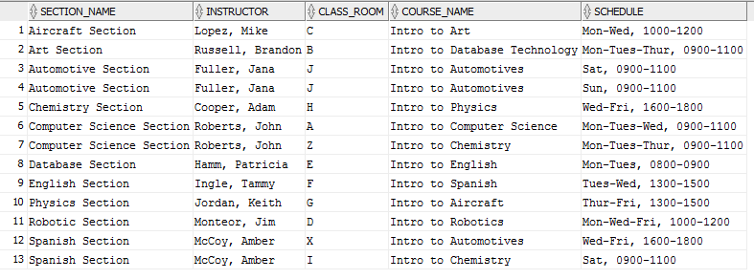

# Conclusion

This was a challenging project and I learned quite a lot from it. The more important things I felt I learned are as follows:

1. SQL Developer is a very powerful tool for database development. When I first started using it I thought it was just a simple tool for creating SQL statements. However, I quickly realized it is a very effective management tool and encompasses everything needed to create and maintain databases. Being able to utilize the query builder when creating select statements made creating queries much more efficient. Additionally, having a bird’s eye view of all the tables proved an effective multiplier in development.
2. I was unfamiliar with triggers before I began working on this project. I now know triggers are very powerful miniature programs embedded within a SQL file which can fire on specific events, similar to event-driven programming. In my project I was able to use a trigger to print a message to the screen when a new row of data was inserted into a table.
3. I knew of the JOIN operator before the beginning of this project, but this project has deepened my understanding of their true power. For example, I was able to create a join between two tables and then use a subquery to return a list of Instructors teaching classes about “Auto” with the LIKE operator. I was also able to use a LEFT JOIN and aggregate function together to compile a list of how many times a course was being taught.
4. I have built many databases in the past, but before this project creating an ERD was almost an afterthought. I now understand having an ERD with a properly laid out database design is a crucial step before you begin writing code. I referenced my ERD during all parts of this project and it proved to make my coding more efficient.
5. My Instr_Classes table is a weak entity. With that I was unsure what would happen if I deleted a referenced entity instance in my parent tables. During this project I learned about the “ON DELETE CASCADE” operator. This is a very important operator as it will ensure any entity instance in the child table is deleted if their associated parent table entity instance is deleted.